
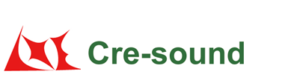
Product Code:
SPL & Current Consumption vs. Input Voltage:

LMB2615W1303-06

Picture:`

Specification:

Rated Voltage | (VDC) | 6
Operating Voltage | (VDC) | 4～8
*Rated Current | (mA) | ≤30
*Sound Output at 10cm | (dB) | ≥90
*Resonance Frequency | (KHz) | 0.4±0.1
Operating Temperature | (℃) | -20～+60
Storage Temperature | (℃) | -30～+70
Weight | (g) | 10.5
RoHS |  | Yes
Remark: The special requirements in the test for no anti reverse connection。
*Value applying at rated voltage.
Test basic state: Temp(20±2℃) , Humidity(40~70%RH) , Air pressure(860~1060hPa).
market@wj-lianhua.com Tel:86-519-86321175 86322167 Fax:86-519-86702455 www.cre-soundbuzzer.com www.wj-lianhua.com

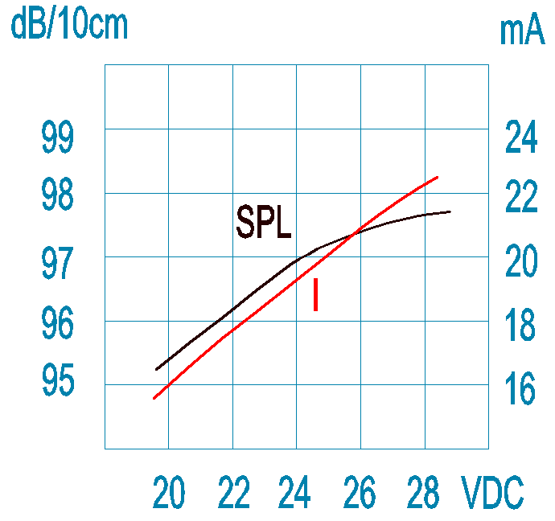

Dimensions (Unit: mm)
Tolerance: ±0.5mm Except Specified
