
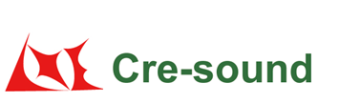
Product Code:
SPL & Current Consumption vs. Input Voltage:

LPB1580BS-HS-05-4.0-R

Picture:`
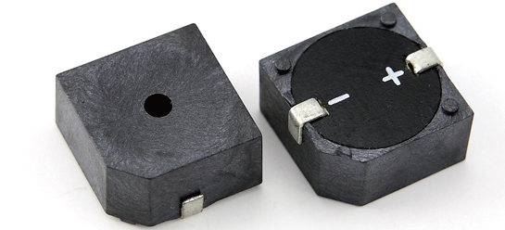

Specification:

Rated Voltage | (VDC) | 5
Operating Voltage | (VDC) | 3～16
*Rated Current | (mA) | ≤5
*Sound Output at 10cm | (dB) | ≥80
*Resonance Frequency | (KHz) | 4.0±0.5
Tone |  | Continuous
Operating Temperature | (℃) | -40～+85
Storage Temperature | (℃) | -40～+90
Weight | (g) | 1.7
Housing Material |  | PPS
RoHS |  | Yes
MSL(Moisture Sensitivity Level) |  | 5a(≤30℃/60%RH 24H Floor life)
Remark: The special requirements in the test for no anti reverse connection。
*Value applying at rated voltage.
Test basic state: Temp(20±2℃) , Humidity(40~70%RH) , Air pressure(860~1060hPa).
market@wj-lianhua.com Tel:86-519-86321175 86322167 Fax:86-519-86702455 www.cre-soundbuzzer.com www.wj-lianhua.com

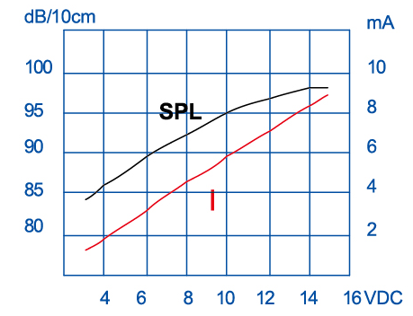

Dimensions (Unit: mm)
Tolerance: ±0.5mm Except Specified
