
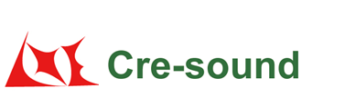
Product Code:
Frequency Response:

LPT3590BW1003-TA-12-1.1-50-R

Picture:`
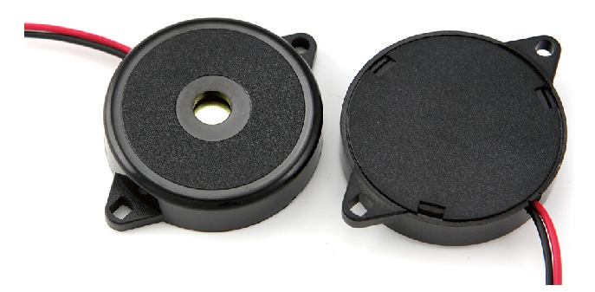

Specification:

Rated Voltage | (Vp-p) | 12
Max Input Voltage | (Vp-p) | 30
*Rated Current | (mA) | ≤12
Capacitance at 100Hz | (pF) | 50000±30%
*Sound Output at 10cm | (dB) | ≥85
Resonance Frequency | (KHz) | 1.1±0.5
Operating Temperature | (℃) | -20～+70
Storage Temperature | (℃) | -30～+80
Weight | (g) | 6
Housing Material |  | ABS
RoHS |  | Yes
*Value applying at rated voltage , 1.1KHz, 1/2 duty , square wave
Test basic state: Temp(20±2℃) , Humidity(40~70%RH) , Air pressure(860~1060hPa).
market@wj-lianhua.com Tel:86-519-86321175 86322167 Fax:86-519-86702455 www.cre-soundbuzzer.com www.wj-lianhua.com

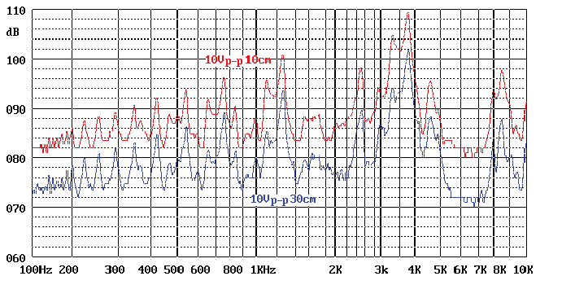

Dimensions (Unit: mm)
Tolerance: ±0.5mm Except Specified
