
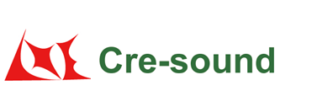
Product Code:
Frequency Response:

LPT3011A-TB-12-2.0-35-13.0-R

Picture:`
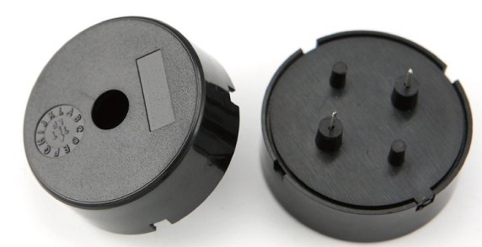

Specification:

Rated Voltage | (Vp-p) | 12
Max Input Voltage | (Vp-p) | 30
*Rated Current | (mA) | ≤12
Capacitance at 100Hz | (pF) | 35000±30%
*Sound Output at 10cm | (dB) | ≥95
Resonance Frequency | (KHz) | 2.0±0.5
Operating Temperature | (℃) | -40～+85
Storage Temperature | (℃) | -40～+90
Weight | (g) | 4.8
Housing Material |  | PBT
RoHS |  | Yes
*Value applying at rated voltage , 2.0KHz, 1/2 duty , square wave
Test basic state: Temp(20±2℃) , Humidity(40~70%RH) , Air pressure(860~1060hPa).
market@wj-lianhua.com Tel:86-519-86321175 86322167 Fax:86-519-86702455 www.cre-soundbuzzer.com www.wj-lianhua.com

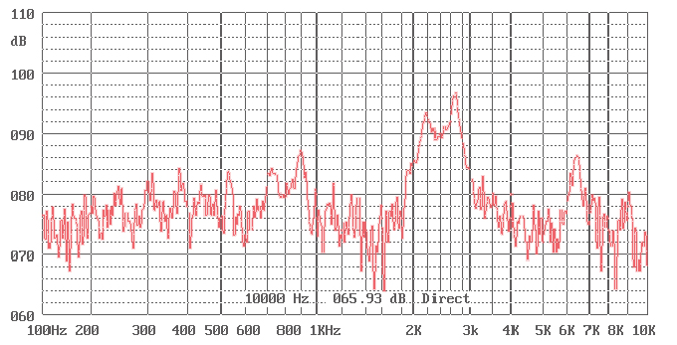

Dimensions (Unit: mm)
Tolerance: ±0.5mm Except Specified
